B.SUSHMA

2303A54040 B-48
Lab1
AssignmentNumber1.3

TASK:1
PROMPT:Write a Python program that asks the user for a number and prints the Fibonacci sequence up to that number, without using any functions
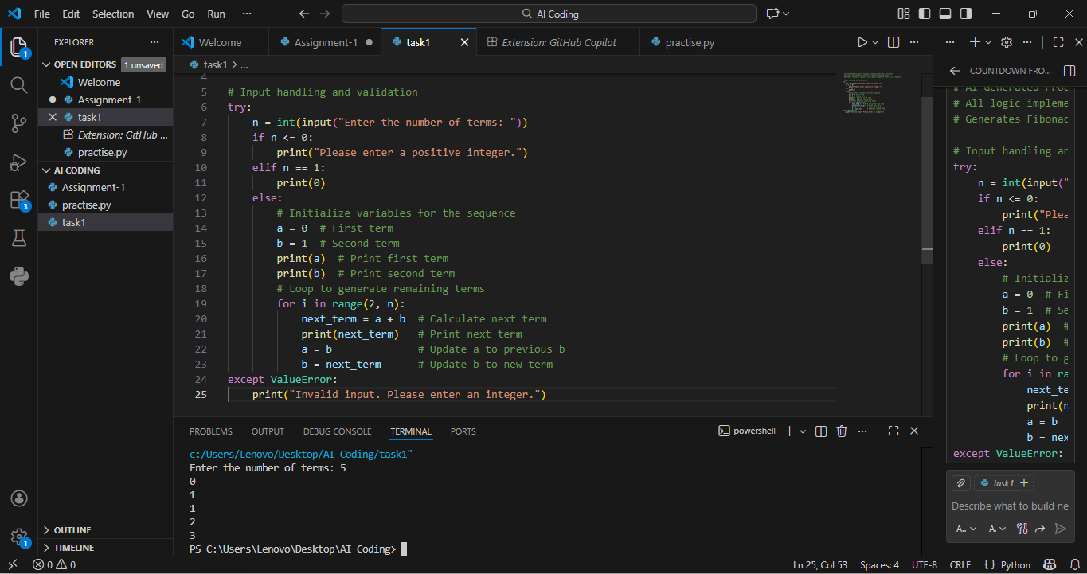
EXPLANATION: Using GitHub Copilot, I was able to generate a Python program that prints the Fibonacci sequence.
The program follows all the given rules and works correctly for any valid input.

TASK:2
PROMPT: AI Code Optimization & Cleanup (Improving Efficiency)
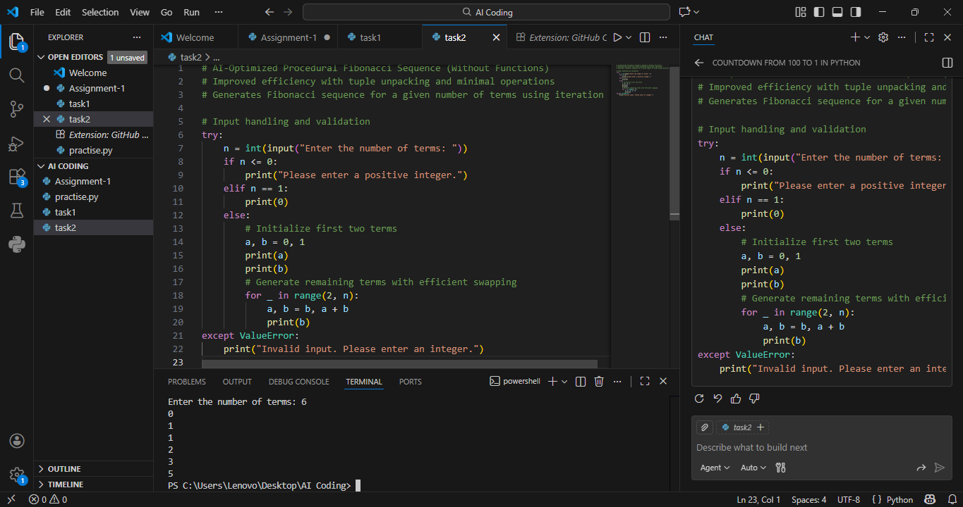
EXPLANATION: Using GitHub Copilot, the original Fibonacci code was improved by:
- Removing extra variables
- Simplifying logic
- Making the code more readable
This task shows how AI can help not only write code but also improve and clean existing code, which is very useful in real-world development.

TASK:3
PROMPT: Write a Python program that uses a function to print the Fibonacci sequence and asks the user for a number

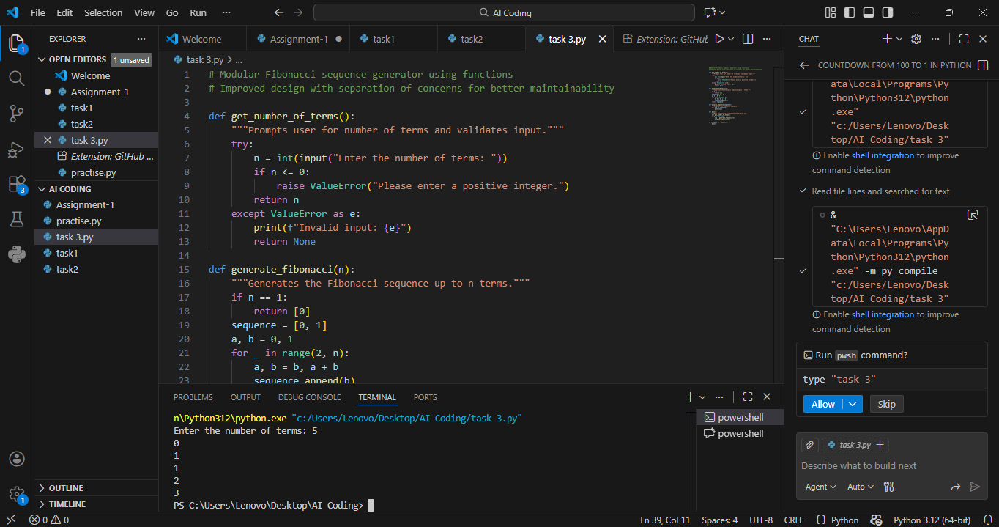

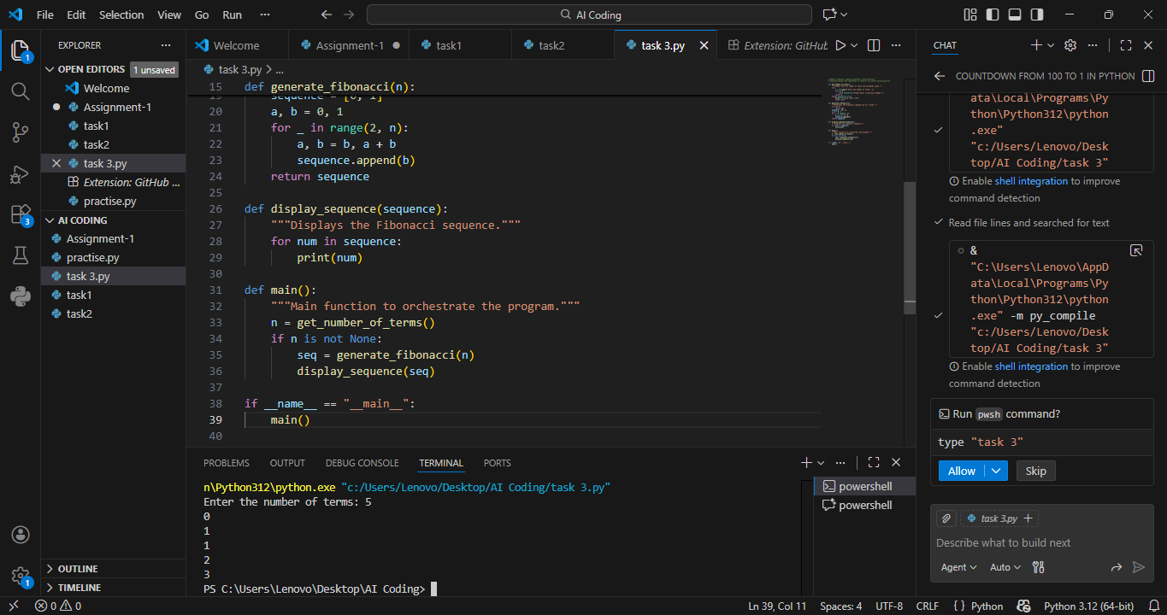
EXPLANATION: Using GitHub Copilot, a function-based Fibonacci program was generated.
This task shows how AI helps in writing modular, reusable, and well-commented code, which is important for large applications.

TASK:4
PROMPT:Print Fibonacci code with functions and without functions
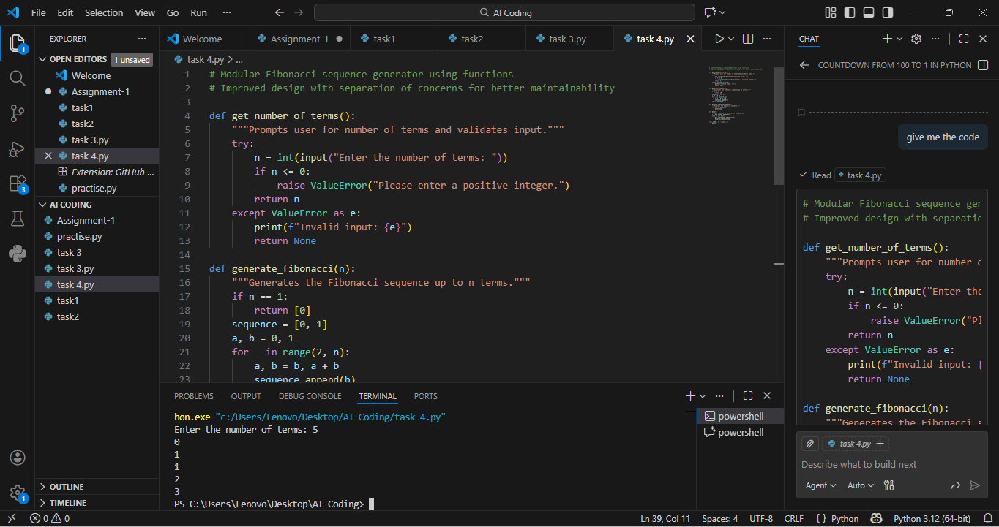
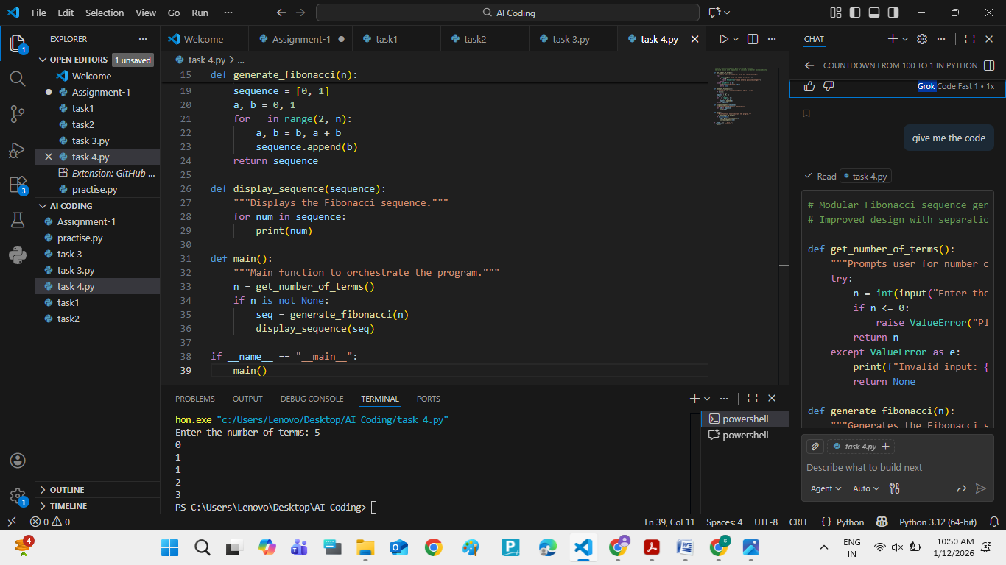
- EXPLANATION: Procedural Fibonacci code is good for learning basics and small programs.
- Modular Fibonacci code is better for real projects, teamwork, and large systems.
- Using functions improves readability, reusability, and maintainability.
This comparison shows why modular programming is preferred in professional software development.

TASK:5
PROMPT: Generate an iterative Fibonacci implementation ,recursive Fibonacci implementation compare their time complexity, performance for large n
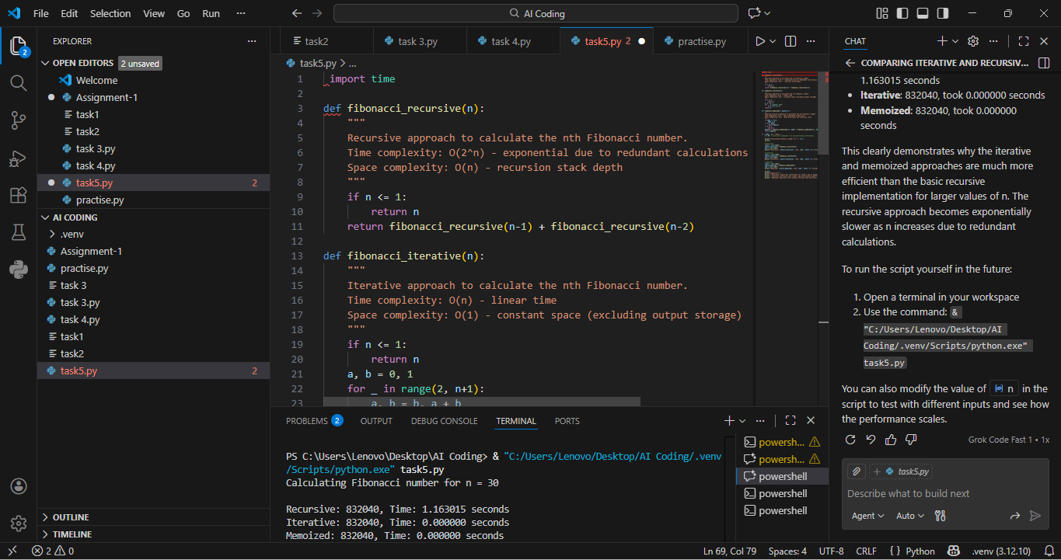
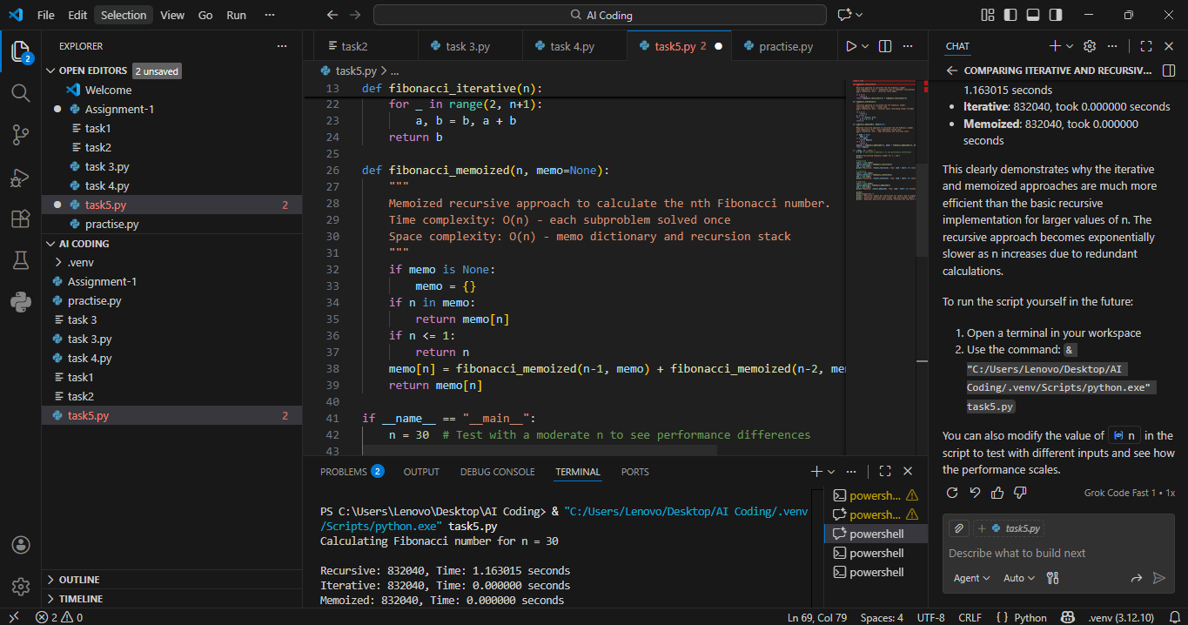
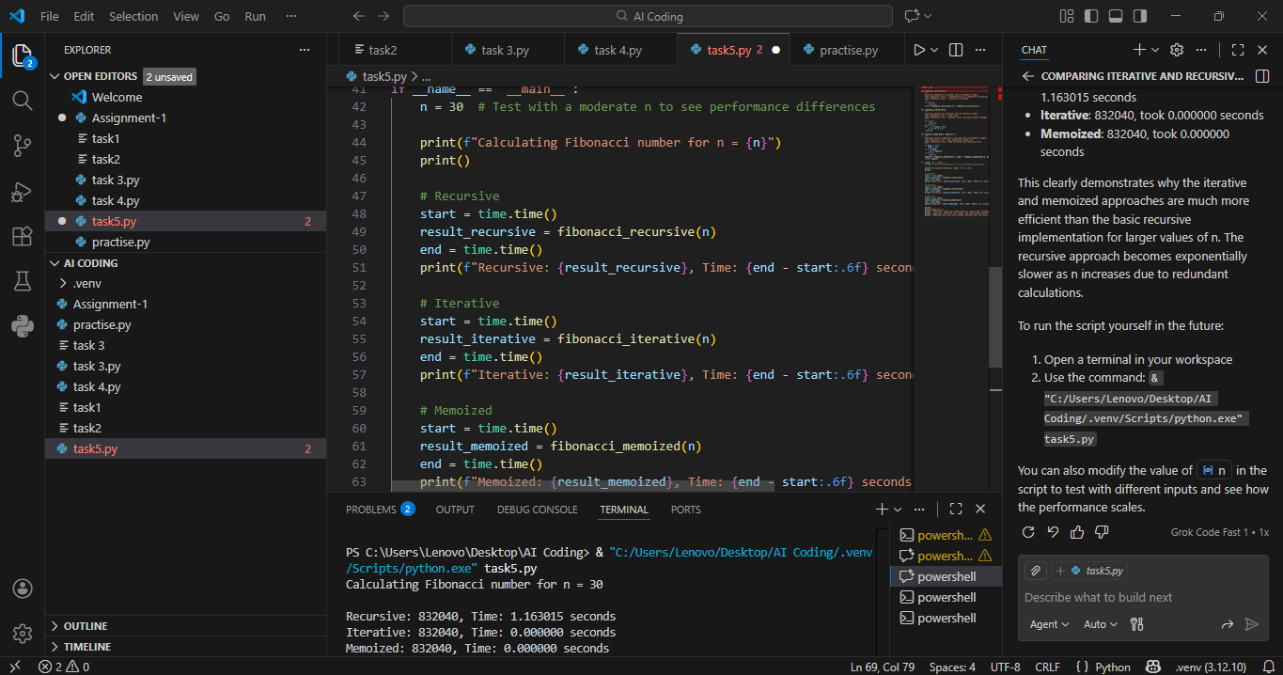
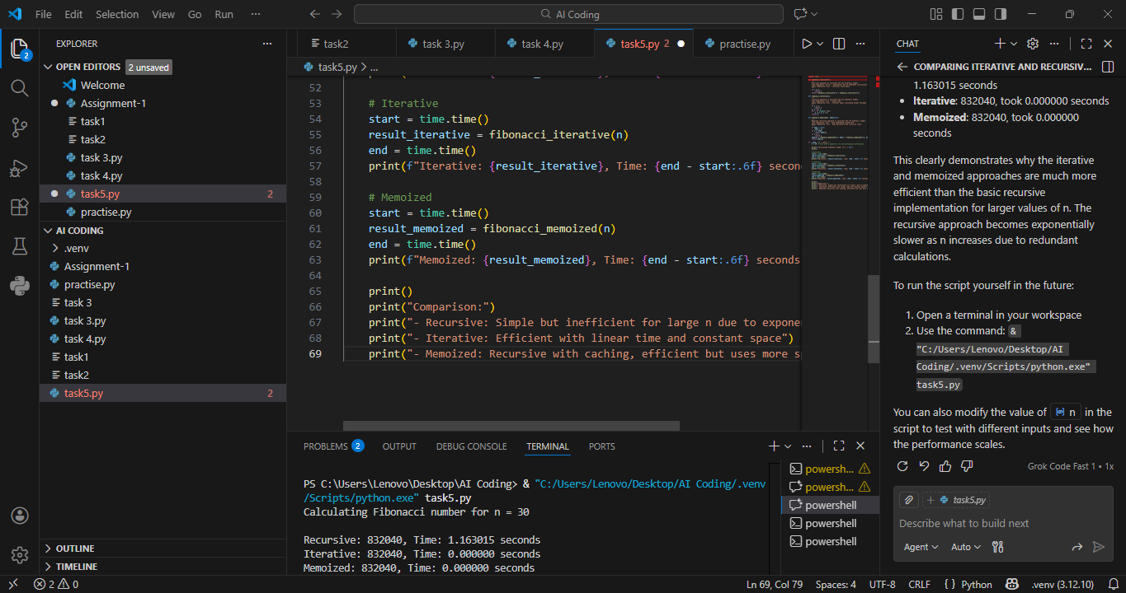
EXPLANATION : The iterative Fibonacci approach is efficient, scalable, and suitable for real-world applications. The recursive approach is mainly useful for learning and understanding recursion concepts but is not ideal for performance-critical systems.

